**Summit Station Weekly Science Report**

**Reporting Period:**  December 10 – December 16, 2018

**Completed by:** Gus Allen, Troy Nave

**Comments:**

Clear, calm conditions allowed ICESat traverse to be performed despite chilly temperatures on Saturday.

Wind speeds at Summit ranged from 0.0 m/s, recorded on 2018-12-11, to 19.3 m/s on 2018-12-12. Temperatures ranged from a low of -48.99˚C on 2018-12-16 to a high of -23.89˚C on 2018-12-14. Weekly average wind speed was 7.63 m/s and weekly average temperature was -34.2˚C.

Summit experienced low winds on 2018-12-11 from 02:30 to 03:22. Summit experienced North winds on 2018-12-11 from 03:21 to 03:24, and on 2018-12-16 from 14:49 to 15:12 last week.

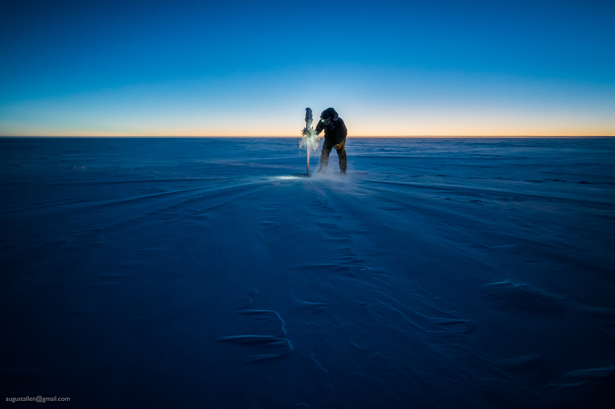

Troy Nave removes ~8cm of rime from a bamboo flag so it can be measured for the ICESat accumulation survey.

**Please visit the clean air log at ftp://isr.sri.com/pub/summit/ftp/science/clean_air_traffic/**

|  |  |
| --- | --- |
| **Facilities** | **Comment** |
| TAWO | HVAC system stable, but still requires repair. |
| MSF |  |
| Green House |  |
| **Experiment** | **Notes** |
| NOAA CCGG flasks | Comment:  Date performed: 2018-12-13 |
| NOAA HATS flasks | Comment: every other week; performed the prior week  Date performed: 2018-12-08 |
| NOAA Surface Ozone | Comment: Calibrated on 2018-12-04  % of time operating: 100% |
| NOAA Aethelometer | Comment: Offline since 2018-01-10. Instrument offsite for repair.  % of time operating: 0% |
| NOAA Meteorology | Comment:  % of time operating: 100% |
| NOAA CLAP & Neph | Comment: Nephelometer span check completed 2018-12-11.  % of time operating: 100% |
| Radionuclide Filter | Comment:  % of time operating: 100% |
| Aerosol DRUM Sampler | Comment:  % of time operating: 100% |
| Bamboo Forest | Comment:  Date performed: 2018-12-14 |
| SnowFox | Comment:  Date performed: 2018-12-12 |
| ICESat Accumulation | Comment:  Date performed: 2018-12-15 |
| GFZ Potsdam Seismometer | Comment:  % of time operating: 100% |
| DTU Magnetometer | Comment:  % of time operating: 100% |
| UNAVCO | Comment: |
| Helmig CUGC | Comment:  % of time operating: 100% |
| Steffen Tower Instruments | Comment:  % of time operating: 100% |
| Steffen Solar Instruments | Comment:  % of time operating: 100% |
| ICECAPS-ACE Total Sky Imager | Comment: Offline for the winter  % of time operating: 0% |
| ICECAPS-ACE Radiosonde | Comment:  Dates performed: Twice daily. |
| ICECAPS-ACE MWR | Comment:  % of time operating: 100% |
| ICECAPS-ACE SODAR | Comment: Briefly powered down on 12-13 to allow routine snow removal  % of time operating: 99% |
| ICECAPS-ACE POSS | Comment:  % of time operating: 100% |
| ICECAPS-ACE MASC | Comment: Instrument is offsite for repair and is due to return Summer 2019.  % of time operating: 0% |
| ICECAPS-ACE MMCR | Comment:  % of time operating: 100% |
| ICECAPS-ACE CAPABL | Comment: Instrument is presently operating normally using laser 2.  % of time operating: 100% |
| ICECAPS-ACE MPL | Comment:  % of time operating: 100% |
| ICECAPS-ACE Ceilometer | Comment:  % of time operating: 100% |
| ICECAPS-ACE PAERI | Comment:  % of time operating: 100% |
| ICECAPS-ACE IcePIC | Comment: No images captured this week  Date(s) performed: |
| ICECAPS-ACE CLASP | Comment: Instrument removed from MSF for service.  % of time operating: 0% |
| ICECAPS-ACE CPC | Comment: Instrument removed from MSF for service.  % of time operating: 0% |
| ICECAPS-ACE OPC | Comment: 12-13: Instrument fan observed not turning, so it was removed to dry out and assess. 12-15: Instrument remounted in a horizontal position to allow assessment of riming.    % of time operating: 85% |
|  |  |  |
|  |  |  |